**Functional Document**

|  |  |
| --- | --- |
| **Application** | NGERP - Centra |
| **Service Bundle** | Purchase Management |
| **Service Request** | Goods Receipt |

**Description:**

In **Compiere (NGERP - Centra)**, **Goods Receipt** (GR) records the receipt of goods against an **NTA Purchase Order** (PO).

**Workflow Process:**

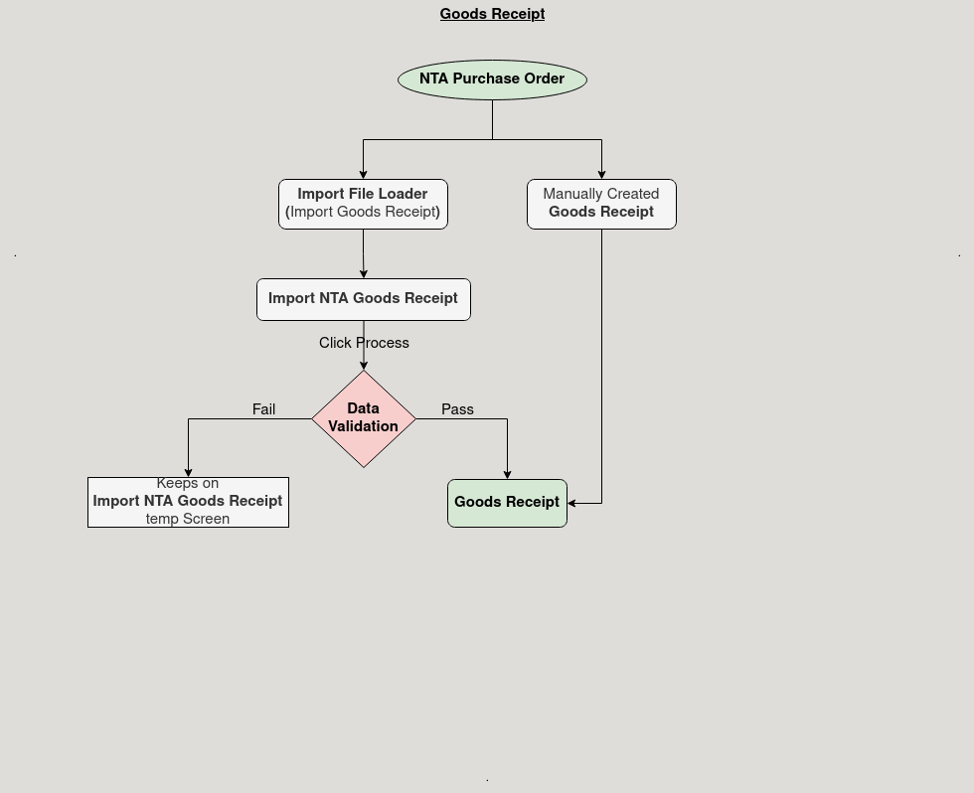

**Business Rules:**

* It is visible only in **HQ.**
* **Creation** is also possible in **HQ.**
* Auto-fills vendor location and price list in NTA PO.
* Default currency is VND.
* GR quantity cannot exceed the PO quantity.
* Lines must be created via the "Create Line From" button.